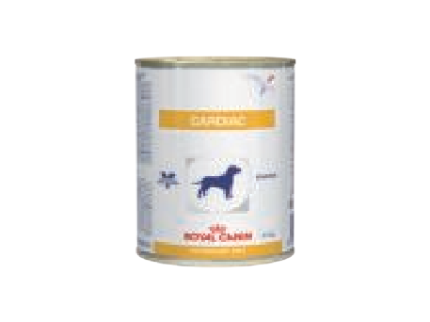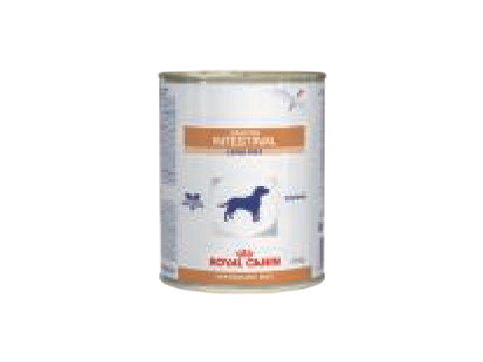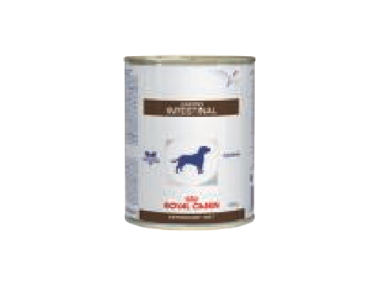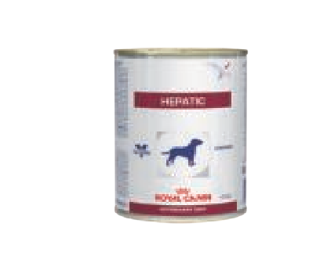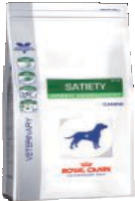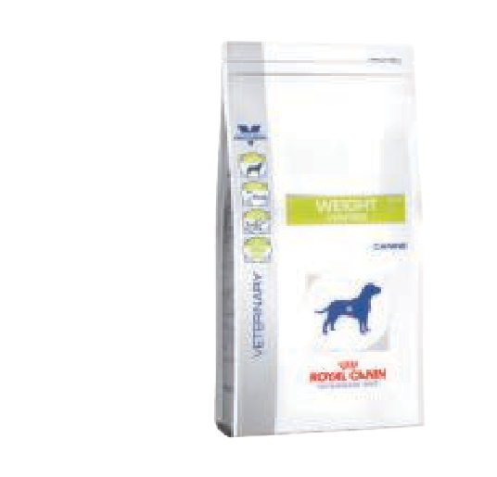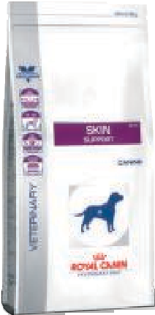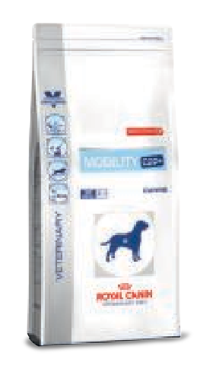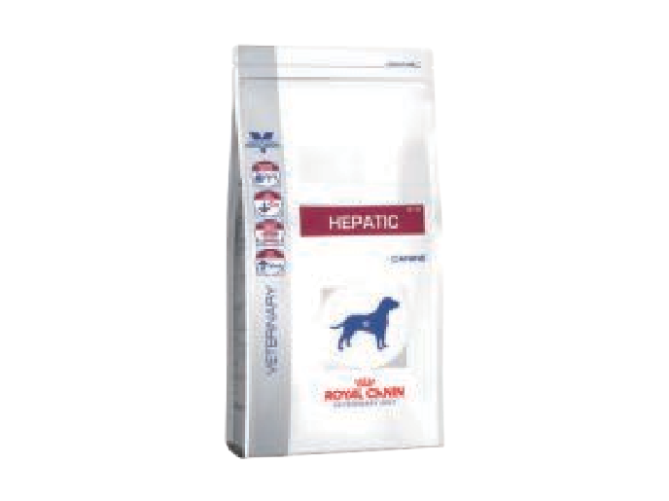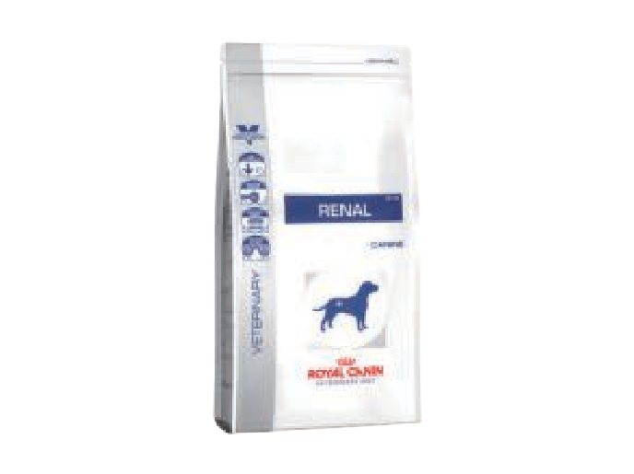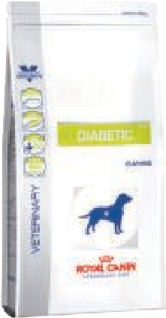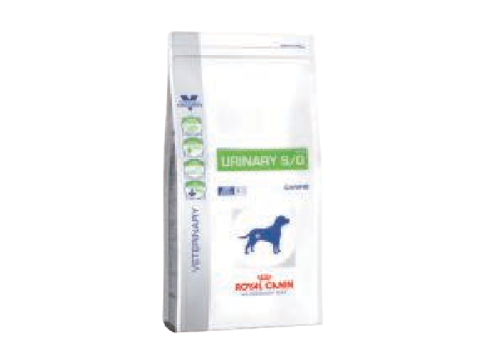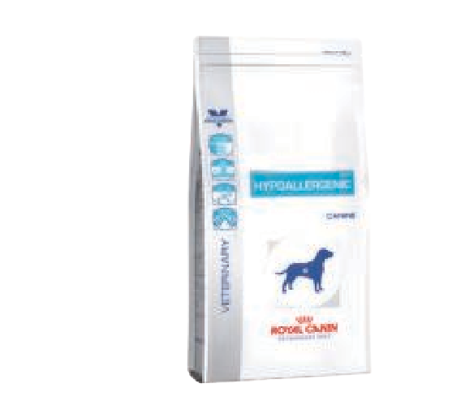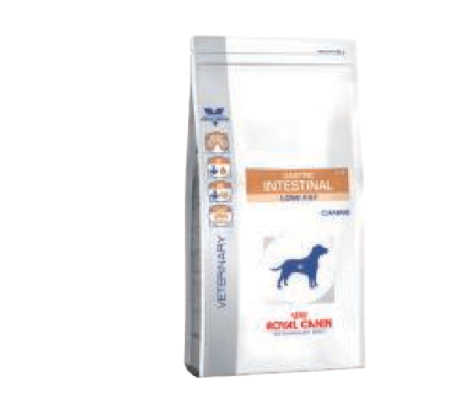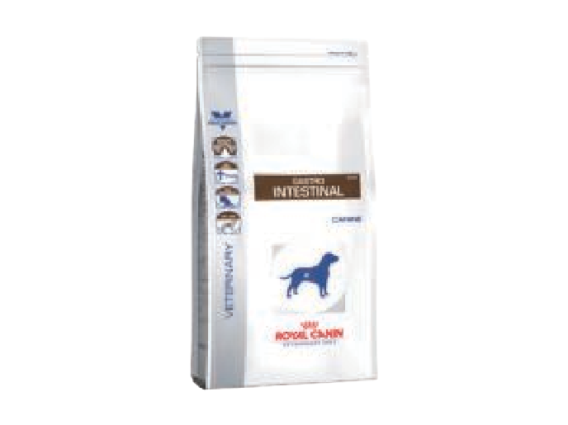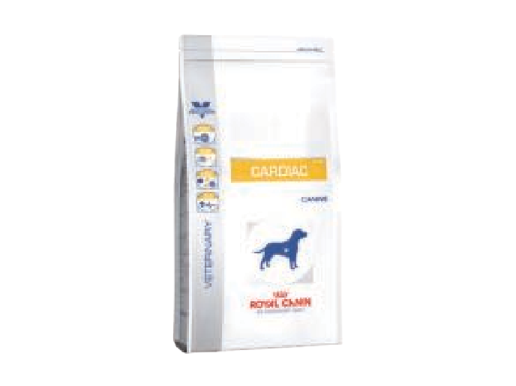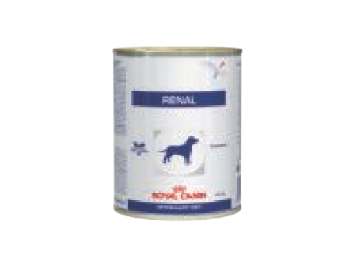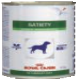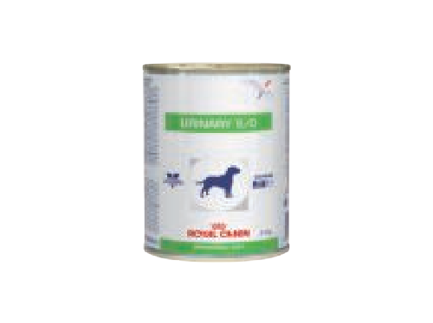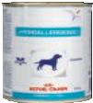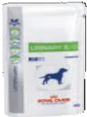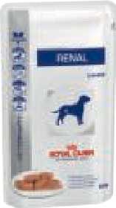

w.e.f. January 01, 2019



M.R.P. LIST 2019



|  |  |  |
| --- | --- | --- |
| Products | SKU (in Kg) | M.R.P |
| **V-DIET CANINE** | | |
| WET Cardiac | 0.41 | ` 420 |
| DRY Cardiac | 2 | ` 1,580 |
| DRY Diabetic | 1.5 | ` 1,120 |
| WET Gastro Intestinal Low Fat | 0.41 | ` 370 |
| DRY Gastro Intestinal Low Fat | 1.5 | ` 1,220 |
| WET Gastro Intestinal | 0.40 | ` 390 |
| DRY Gastro Intestinal | 2 | ` 1,590 |
| WET Hepatic | 0.42 | ` 370 |
| DRY Hepatic | 1.5 | ` 1,230 |
| DRY Hepatic | 6 | ` 4,610 |
| Hypoallergenic | 0.40 | ` 640 |
| DRY Hypoallergenic | 2 | ` 1,620 |
| DRY Hypoallergenic | 7 | ` 5,460 |
| DRY Mobility C2P+ | 2 | ` 1,720 |
| DRY Mobility C2P+ | 7 | ` 5,470 |
| WET Renal | 0.41 | ` 410 |
| WET Renal CIG (10 Pouches) x 150 gms | 1.5 | ` 1,660 |
| DRY Renal | 2 | ` 1,590 |
| DRY Renal | 7 | ` 4,960 |
| WET Satiety | 0.41 | ` 350 |
| DRY Satiety | 1.5 | ` 1,280 |
| DRY Satiety | 6 | ` 4,770 |
| DRY Satiety | 12 | ` 8,280 |
| DRY Skin Support | 2 | ` 2,260 |
| WET Urinary | 0.41 | ` 350 |
| WET Urinary (10 Pouches) x 150 gms | 1.5 | ` 1,600 |
| DRY Urinary | 2 | ` 1,580 |
| DRY Weight Control | 1.5 | ` 1,180 |

|  |  |  |
| --- | --- | --- |
| **V-DIET FELINE** | | |
| WET Renal (12 Pouches) x 85 gms | 1.02 | ` 1,440 |
| DRY Renal | 2 | ` 1,600 |
| DRY Satiety | 1.5 | ` 1,300 |
| DRY Satiety | 3.5 | ` 2,820 |
| WET Urinary (12 Pouches) x 100 gms | 1.2 | ` 1,740 |
| Urinary Moderate Calorie (12 Pouches) x 100 gms | 1.2 | ` 1,560 |
| DRY Urinary | 1.5 | ` 1,180 |
| WET Sensitivity (12 Pouches) | 1.2 | ` 1,620 |
| Renal Tuna CAT (12 Pouches) X 85 gms | 1 | ` 1,200 |
| Skin & Coat CAT Pouch (12 Pouches) X 100 gms | 1.2 | ` 1,560 |
| G-Intestinal CAT Pouch (12 Pouches) X 100 gms | 1.2 | ` 1,560 |

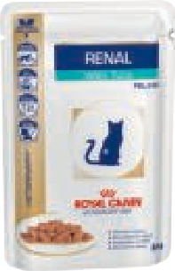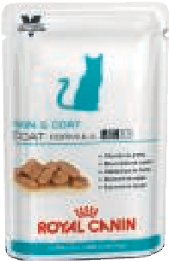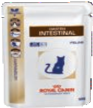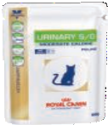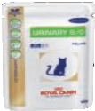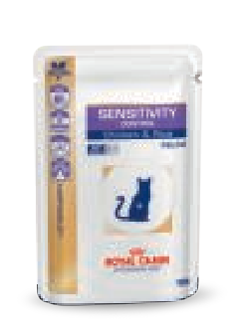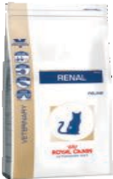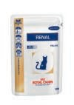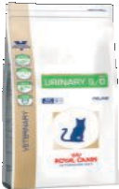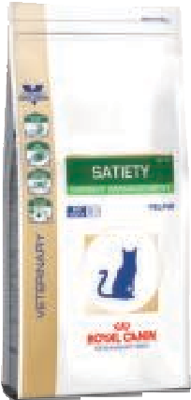

# ROYAL CANIN®’s VETERINARY DIET is available exclusively with veterinarians.

For more details about ROYAL CANIN® and our products mail us at:

# [feedback.india*@*royalcanin.com](mailto:feedback.india@royalcanin.com)

VETERINARY DIET CANINE **RECOMMENDATIONS**



Acute pancreatitis: - Gastro-Intestinal Low Fat

* Gastro-Intestinal Low Fat

Anorexia: - Convalescence Support

* Recovery
* Gastro-Intestinal
* Gastro-Intestinal

Ascites:

With liver disease: - Hepatic

* Hepatic

With - Convalescence Support

Hypoproteinaemia: - Recovery

* Gastro-Intestinal
* Gastro-Intestinal
* Cardiac

With heart failure: - Cardiac

* Renal

With renal failure: - Renal

Atopy: - Skin Support

* Hypoallergenic

Cachexia: - Convalescence Support

* Recovery
* Gastro-Intestinal
* Gastro-Intestinal

Chronic gastritis: - Gastro-Intestinal Low Fat

* Gastro-Intestinal Low Fat
* Hypoallergenic
* Gastro-Intestinal
* Gastro-Intestinal

Chronic pancreatitis: - Gastro-Intestinal Low Fat

* Gastro-Intestinal Low Fat

Colitis: - Diabetic Special Low Carbohydrate

* Gastro-Intestinal Low Fat
* Gastro-Intestinal Low Fat
* Weight Control (Diabetic Support)
* Hypoallergenic Flee Bite Allergic Demartosis: - Skin Support Food allergies: - Hypoallergenic Food elimination trial: - Hypoallergenic Food intolerance: - Hypoallergenic

Gastric or duonenal ulcer: - Gastro-Intestinal Low Fat

* Gastro-Intestinal Low Fat
* Gastro-Intestinal
* Gastro-Intestinal

Gastric stasis: - Gastro-Intestinal Low Fat

* Gastro-Intestinal Low Fat

Gastroenteritis: - Hypoallergenic

* Gastro-Intestinal
* Gastro-Intestinal

Gastrointestinal surgery: - Convalescence Support

* Gastro-Intestinal
* Gastro-Intestinal Gluten-sensitive enteropathy: - Hypoallergenic Healing: - Skin Support

Heart Disease/Failure:

(stage 1 to 3): - Cardiac

(stage 4): - Cardiac

Hepatic copper accumulation: - Hepatic

* Hepatic

Hepatic encephalopathy: - Hepatic

* Hepatic
* Renal
* Renal

Hepatitis: - Convalescence Support

* Hepatic
* Hepatic

Maldigestion: - Gastro-Intestinal

* Gastro-Intestinal
* Gastro-Intestinal Low Fat
* Gastro-Intestinal Low Fat
* Hypoallergenic

Mandibular trauma/disease: - Convalescence Support

Megacolon: - Gastro-Intestinal

* Gastro-Intestinal

Megaoesophagus: - Convalescence Support

* Gastro-Intestinal
* Gastro-Intestinal
* Gastro-Intestinal Low Fat
* Gastro-Intestinal Low Fat

Neoplasia: - Convalescence Support

* Gastro-Intestinal
* Gastro-Intestinal

Obesity: - Satiety

* Satiety

Oedema: - Cardiac

Oesophagitis: - Convalescence Support

* Gastro-Intestinal Low Fat
* Gastro-Intestinal Low Fat

Otitis (External): - Skin Support

Oxalate urolithiasis: - Renal

* Renal
* Urinary S/O
* Urinary S/O

Perianal stula: - Skin Support

Poor appetite: - Convalescence Support

* Gastro-Intestinal
* Gastro-Intestinal
* Recovery

Portosystemic shunt: - Hepatic

* Hepatic

VETERINARY DIET CANINE **RECOMMENDATIONS**

Constipation:

Responsive to - Satiety Management

dietary bre: - Satiety Management

- Weight Control (Diabetic Support)

Not responsive to - Gastro-Intestinal

dietary bre: - Gastro-Intestinal

Convalescence: - Gastro-Intestinal

* Gastro-Intestinal
* Recovery
* Convalescence Support

Cushing s syndrome: - Convalescence Support

* Gastro-Intestinal
* Gastro-Intestinal

Cystine urolithiasis: - Renal

* Renal

Cystitis: - Urinary S/O

* Urinary S/O

Dermal function maintenance: - Skin Support

Dermatitis: - Skin Support

* Hypoallergenic

Diabetes mellitus: - Weight Control (Diabetic Support)

* Diabetic Special Low Carbohydrate

Diarrhoea: - Gastro-Intestinal

* Gastro-Intestinal
* Gastro-Intestinal Low Fat
* Gastro-Intestinal Low Fat
* Weight Control (Diabetic Support)
* Diabetic Special Low Carbohydrate
* Hypoallergenic

Eosinophilic granuloma: - Hypoallergenic

Exocrine pancreatic insufficiency: - Hypoallergenic

* Gastro-Intestinal
* Gastro-Intestinal
* Gastro-Intestinal Low Fat
* Gastro-Intestinal Low Fat

Hyperglycaemia: - Weight Control (Diabetic Support)

* Diabetic Special Low Carbohydrate

Hyperlipidaemia: - Weight Control (Diabetic Support)

Hypertension: - Cardiac

* Cardiac

Inflammatory bowel disease: - Hypoallergenic

* Gastro-Intestinal
* Gastro-Intestinal

Intestinal obstruction: - Convalescence Support

(Following surgical management) - Gastro-Intestinal

* Gastro-Intestinal

Inflammatory bowel disease: - Weight Control (Diabetic Support)

* Hypoallergenic
* Gastro-Intestinal
* Gastro-Intestinal

Jaundice: - Hepatic

* Hepatic

Joint health: - Mobility

Joint Surgery: - Mobility

Leishmaniasis: - Hypoallergenic

* Renal

Liver disease: - Hepatic

* Hepatic

Lymphangiectasia: - Gastro-Intestinal Low Fat

* Gastro-Intestinal Low Fat

Lymphoplasmocytic colitis: - Diabetic Special Low Carbohydrate

* Weight Control (Diabetic Support)
* Hypoallergenic

Malabsorption: - Gastro-Intestinal

* Gastro-Intestinal
* Gastro-Intestinal Low Fat
* Gastro-Intestinal Low Fat

Pre/post surgery: - Recovery

* Convalescence Support
* Gastro-Intestinal
* Gastro-Intestinal

Protein-losing enteropathy: - Gastro-Intestinal Low Fat

* Gastro-Intestinal Low Fat

Pyodermatitis: - Skin Support

Renal failure: - Renal

* Renal

Small intestinal bacterial overgrowth: - Gastro-Intestinal

* Gastro-Intestinal
* Gastro-Intestinal Low Fat
* Gastro-Intestinal Low Fat
* Hypoallergenic

Stress: - Convalescence Support

* Gastro-Intestinal
* Gastro-Intestinal

Struvite urolithiasis: - Urinary S/O

* Urinary S/O

Tube feeding: - Recovery

* Convalescence Support - mix with one volume of water then blend
* Gastro-Intestinal Low Fat - mix with one volume of water then blend

Urate urolithiasis: - Hypoallergenic

* Renal
* Renal

Vomitting: - Gastro-Intestinal

* Gastro-Intestinal
* Gastro-Intestinal Low Fat
* Gastro-Intestinal Low Fat
* Hypoallergenic

Weight maintenance (obesity stage 2): - Weight Control (Diabetic Support)